**English**

Andres facundo and Santiago Hurtado

**What is the difference?**

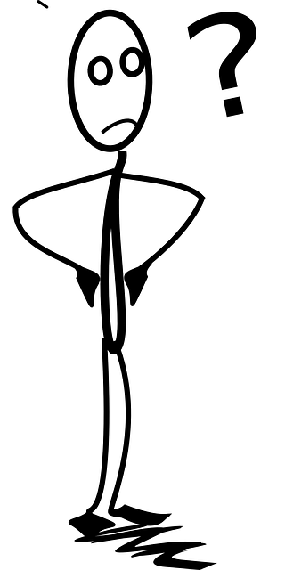

**The British Isles**



**The United Kingdom**

**Great Britain**

**England**

**Instructions:**

* Scan the QR code and watch the video on the difference between England, the United Kingdom, Great Britain, and the British Isles.
* Answer all the questions in full sentences.
* You may pause the video or watch it again.

**The British Isles**

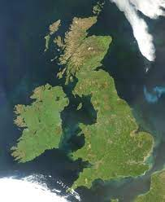

* **Label** the two islands.
* **Explain** in your own words, what the British Isles are.

Culturally, the British Isles have a rich history and have been an important center of trade and culture for centuries.

**Great britain**

* **Why** is the term controversial?

associated with British imperialism

**Ireland**

**The United Kingdom**

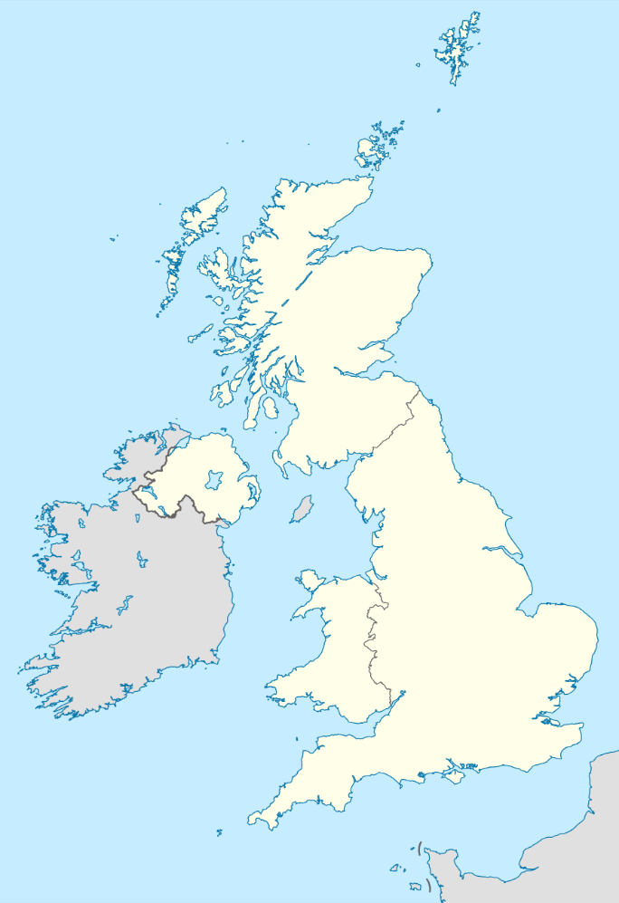

* **Name** the constituent countries of the United Kingdom:

A England

B Northern Ireland

C Scotland

**C**

D Wales

* **What** is the full name of the United Kingdom?

**B**

United Kingdom of Great Britain and Northern Ireland

**A**

* **When** and **how** was the United Kingdom created?

**D**

The United Kingdom was officially created on January 1, 1801 with the passing of the Acts of Union of 1800.

* **Why** was the United Kingdom or Great Britain and Ireland renamed?

In 1922 after the war for Irish independence, it became an independent country, known as the Irish Free State (later the Republic of Ireland) ... As a result, it was renamed the United Kingdom of Great Britain and Ireland. north

* To which constituent countries do the following flags belong?

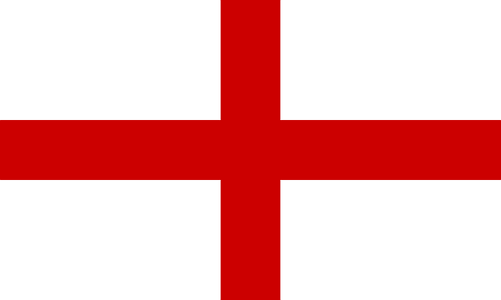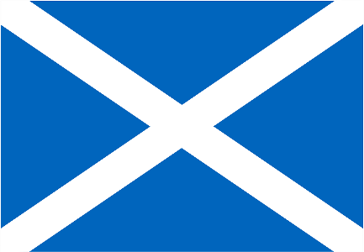

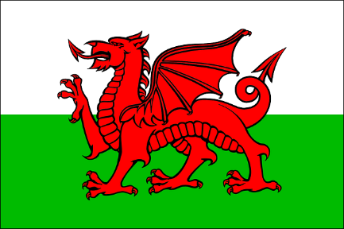 WALES SCOTLAND ENGLAND

**Great Britain**

* 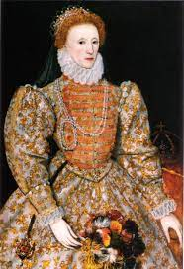**Which** two kingdoms were united to form Great Britain?

The two kingdoms that united to form Great Britain were England and Scotland. The union was formalized by the Acts of Union of 1707, which came into force on May 1, 1707.

* **How** did it come that these two kingdoms were united?

They were united through an act that was signed in 1707.

* **Which** constituent country forms part of the United Kingdom, but not of Great Britain?

The country that is part of the United Kingdom but not Great Britain is Northern Ireland.

**England**

* What is England part of?

England forms part of united kingdom

